AYSO REGION 1441
COACHES
INFORMATION
SUMMARY Fall 2023

PARENTS MEETING
Please have a meeting with your team by August 7, 2023, so players know they are on a team. All parents and both coaches should be there . BE PREPARED ! Below is a list of the items that should be covered -- as briefly as possible.

- Review registration forms for accuracy, particularly with regard to having signed forms (by parent or guardian), current phone numbers, emergency information, and insurance carriers. HAVE PARENTS SIGN ALL FORMS (Registration & Concussion Policy). After the meeting, talk to parents with children who have asthma or any other condition which may require special attention.
- Determine how many parents are interested in refereeing at a competitive level (10U+). These persons shall submit a volunteer form and be Safe Haven & CDC Concussion Certified. Plus, they must be certified as a referee for the appropriate age level (comp or non-comp). Record the names on the Team Information Form.

- Select your Team Parent. This person may be either mother, father, or legal guardian of one of the players. This person is responsible for coordinating all team information, either from the coach or from the Region 1441 Board. This person needs to complete the online training, including the LiveScan. Record the name on the Team Information Form.
- Select a second contact for your team. This volunteer will be cc'd on emails and any other communication from the Division Representatives. It cannot be a family member of the coach or have the same email address. This person can be the Team Parent or Assistant coach or anyone else on the team willing to remind the coach of information throughout the season. Record the second contact on the Team Information Form.
- We are always looking for assistance in marking the playing fields. We need help every Please email us at ayso1441board@gmail.com with volunteer information.

- As coach it is your responsibility to have a First Aid kit at practice. It should contain peroxide, band aids, insect bite cream, Instant ice packet, and an ace bandage.
- Discuss any carpooling needs that a parent may have. Stress prompt pick-up of players after practice. It is unfair for you to have to wait on a regular basis for tardy parents. Set a plan of action you will utilize in the event of an unforeseen circumstance. NEVER leave players at the field.
- The "Safe Haven" program requires 1 adult for each 8 players, one of which must be of the same gender as the players. This includes all team activities, including practices. Set up a practice schedule which accommodates you and the team.
- Water containers for each player are highly recommended for each practice, especially during warm weather practices.
- Discuss the need for a schedule for refreshments and cold water or Gatorade type drink. Each family should be on the schedule with the exception of the coaches. It is also a good idea to have the snack parent bring a plastic trash bag and wet wipes. Each team is responsible for their trash.

All teams 6U-12U will start play on Saturday, August 26th
- Team banners/flags are optional. It is advisable to collect money from each family at this time to defray the total cost of the banner/flag (around $100) It is preferred that the players get involved in making the banner/flag.
- Team names can be chose after you have your uniforms, but the names need to be approved through the board to ensure there are no duplicates (for example we cannot have two 8U teams with the name dragon). Names will be allowed on a first come first serve basis, meaning, if you have a name before uniforms are handed out, you can let us know and you will get dibs. DO NOT MAKE YOUR BANNER UNTIL YOUR NAME IS APPROVED.
- Shin guards must be worn at all practices and games. NO PLAYER MAY PARTICIPATE (PRACTICE OR GAMES) WITHOUT THEM. Further disciplinary action will result if a player or coach fails to observe this rule. Shin guards must be worn INSIDE the socks and they must be of the appropriate length. No short shin guards will be permitted. Socks must fully cover the shin guard. This is a requirement of AYSO National and has been implemented for safety reasons.
- Let your parents know what they can expect from you, and what you expect from them. Ask them to come to the games and cheer for the team, call if their son/daughter will not be at practice/game, set a good example, plan family activities around the game schedule, and let you do the coaching. Talk about everyone being a part of the team (Players, Parents, & Coaches). Parents can be a big help by always looking for, and talking about ONLY the good things that their son/daughter does. NEVER talk about mistakes they make, or their teammates make. NEVER call out a parent in front of other parents or talk badly about your parents to other parents. Give them the same respect you would a player, if you have a concern, talk to them privately and reach out to the board if the problem continues. The key is to always be POSITIVE.
- Let your parents know what they can expect from you, and what you expect from them. Ask them to come to the games and cheer for the team, call if their son/daughter will not be at practice/game, set a good example, plan family activities around the game schedule, and let you do the coaching. Talk about everyone being a part of the team (Players, Parents, & Coaches). Parents can be a big help by always looking for, and talking about ONLY the good things that their son/daughter does. NEVER talk about mistakes they make, or their teammates make. The key is to always be POSITIVE.
- Fall Season games are scheduled for every Saturday, September 10th to November 12th. November 12th will be the first game day of Region play-offs for 10U and up.
- Spectator sideline rules. All parents and children must be 3 feet back from the sideline. Please remind parents to watch their small children so that they are not accidentally knocked down. Please ensure that toys are kept off the playing field.

PRACTICE
- 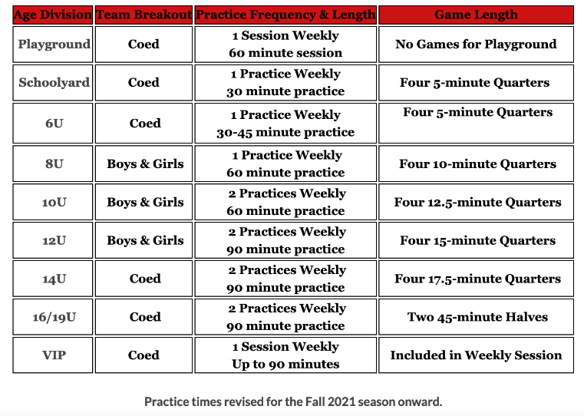.
- Remember to have your team registration forms with you. In your absence, your assistant coach must have his copy with him/her. Spot checks for registration forms may occur, without notice. This National rule is enforced for the protection of the players. Bring your First Aid Kit.
- Each player should bring their own water container to practice. It is recommended that you bring an extra bottle or two, especially during warm weather months.
- Remind parents to be prompt in dropping off their children to practice and in picking them up. Make sure your practice ends on time. Parents are more likely to be late if your practices are always going 15 to 20 minutes over.
- Per Safe Haven, sending players to the restroom or anywhere else on their own, requires they be sent using the Buddy System. The BUDDY SYSTEM CONSISTS OF 3 PLAYERS.
GAMES
- Game schedules may ready by the mandatory coach's meeting. The "Home" team is the team that is listed first on the game schedule, and will occupy the North or West side of the field. See list above for length of games
- Gamecards for 10U and up are mandatory. Please bring them filled out in Jersey order to your games. The cards will be handed out at uniform distribution and the first one will need to be filled out before you can get your uniforms.
- First game of the day: Both the home and visiting teams are responsible for making sure the equipment is set up by game time. It is advisable to designate a parent/s on the team to be responsible for these duties, or assign them on a rotating basis. Please arrive approximately 1 hour before the scheduled game time to set up fields. YOUR GAME WILL BE SHORTENED BY THE NUMBER OF MINUTES IT WAS DELAYED IF THE EQUIPMENT IS NOT SET UP BY GAME TIME .
- Both the Home and Visiting teams of the last scheduled game of the day are responsible for taking the field equipment down, and dropping off the equipment bags as directed by the field staff.
- It is required that both coaches verify the final score and substitutions with the Assistant Referees, and sign the game cards at the end of the game. The final score posted on the game card will be considered the official score. Field Monitors assigned to your game will also sign the game card at the end of the game. DO NOT sign the game card for Field Monitors at the beginning of a game.
- Game cards should be filled out prior to the start of the season. Make sure it is complete.
LIST ALL PLAYERS NUMERICALLY BY UNIFORM NUMBER . List all players on your team, FIRST AND LAST NAME, even if they are not going to be at the game. Give the reason they are missing (Absent, ill, Injured).
- Coaches are required to stay in their technical area (10 yards on either side of the center line of the playing field). All substitute players must also remain near the coach’s area. All players are to turn their backs to the lines-person to report their uniform number before entering or exiting the playing field.
- Players in Divisions 10U through 14U+ must play three quarters of the game unless they arrive late, are injured, or are ill. (Referees do not enforce this; they are to report it only). Due to the roster size and due to the 6-periods of play in 6U & 8U, if all players are in attendance at a game, each player cannot play “three quarters” (75% of the game). In 6U - 8U games where all 6 players are in attendance the same player may not sit out half (1/2) of the game in a subsequent game until ALL players have each sat for half (1/2) of a game. If not all players are in attendance at a game, then all players must play at least 4 of the 6 periods of that game.
- In Divisions 6U through 14U+ no player may sit out of the game two consecutive quarters. The same player may not sit out the first or last quarter of every game. Referees do not enforce this; they are to report it only).
- In Divisions 10U through 12U+, goalkeepers must play 2 quarters of the game out of the keeper position. (Referees do not enforce this; they are to only report it if not followed).
- In the event we have rain and there is a question as to whether we will play soccer games, the following procedure will be followed: The Referee Administrator, Safety Director, and/or the Regional Commissioner will inspect all playing fields at approximately 6:00 am Saturday morning. Your Division Representative will notify you if the games have been canceled. If you do not receive a phone call notifying you of a cancellation, you must assume that the games will be played. In the event of game cancellation, all games for the day will be canceled. It is the coach’s responsibility to call the players. Should lightning occur, referees will stop games and fields will be cleared. Games for that time slot, may be canceled. Do not assume the remainder games for the day will be canceled. Games should be rescheduled due to excessive weather or poor field conditions.
- If a player is bleeding, i.e., from the nose or an open wound, that payer must leave the game until the bleeding has been stopped, the wound has been sufficiently covered, and any blood cleaned from the skin. In addition, if a player has blood on his/her uniform, it must be cleaned and dried, or changed, before the player can resume play.
- Concussion information Any player suspected of having a concussion by the coach, referee or parent must be removed from further participation for at least the remainder of the day, and Parents should be encouraged to seek professional medical treatment at the time of injury and secure medical clearance before being allowed to return to play. In all cases, AYSO will require the parent to sign a new Participation Release Form confirming that the player has been given the appropriate clearance to return to play. Form confirming that the player has been given the appropriate clearance to return to play. Further, if they are diagnosed by a physician with a concussion, a doctor’s release will also be required.
Direct the parents to the Concussion Action Plan and Concussion Information Sheet
(English & Spanish) on the Region’s website under Documents for more information.
- You will be given Field Monitor assignments for throughout the season. Both game cards must have the printed name of the field monitor and team number to receive credit for completion of the assignment.
- Coach/Spectator sideline: Coaches are expected to coach in a positive manner. Spectators are encouraged to cheer also in a positive manner

UNIFORMS AND EQUIPMENT
- Coaches will be informed by their Division Representative when uniforms will be available for distribution. The coach must have a pre-approved team named and present the completed Team Information form (enclosed in this packet, the Region 1441 signed Code of Conduct forms and eight (9) completed game cards to receive his/her team uniforms.
- When distributing uniforms, the players should be lined up in tallest/largest to shortest/smallest order. The uniforms should be distributed accordingly. FIT, not player number, is the primary concern in outfitting a team with uniforms. The team parent or one of the mothers may be helpful in fitting uniforms.
- If there is a problem with a uniform at any time throughout the season, please advise your Division Representative.
- No player’s names or team names will be allowed on player uniforms per National Rules & Regulations.
- Soccer or all-turf shoes are recommended at games and practices. Tennis shoes are permitted but not recommended.
- Soccer ball sizes are as follows:
Division 6U - 8U - size 3 ball
Division 10U - 12U - size 4 ball
Division 14U+ - size 5 ball
- Under-amour can be worn under a jersey but color must match jersey color. Leggings or warm up pants may be worn at the discretion of the referee.

MISCELLANEOUS INFORMATION
- It is possible that a player may elect to drop out. Please have the parent contact the registrar. A player will not be dropped or added unless the parent contacts the registrar directly. Administratively, if a replacement player is available that is similar in rating and will not affect the team balance, the registrar will e-mail the coach the registration form for the new player. The coach must have the registration form before the player can practice or play a game.
- Please be sure that you check your e-mail regularly as the majority of communication between you and the Region will be via e-mail. It is very important that you receive communications in a timely manner. IT IS YOUR ULTIMATE RESPONSIBILITY AS A COACH TO ENSURE THAT YOU RECEIVE AND DISTRIBUTE COMMUNICATIONS.
- Please utilize the assistance of the coaching staff personnel. They are there to help in areas you might need advice or assistance.

